**Malawi DHS Interviewer Tablet Quiz**

**Instructions**

*Please answer the questions below in approximately 20 minutes.*

1. Name two ways that duplicated cases can occur when a team is working in a cluster
2. If a case has to be deleted or corrected to solve a problem of duplicates, on which tablet(s) should the deletion or correction be done? *(Circle the correct answer*)
3. The supervisor’s tablet only
4. Both the supervisor’s tablet and the interviewer’s tablet
5. The tablets of all members of the interviewing team
6. The interviewer’s tablet only
7. In what circumstances may you decide that a household originally listed as one household must be “split” into more than one household for the purposes of listing *(Circle the correct answer*)
8. Where there are a very large group of people living in the dwelling and you wish to split the household to allow more than one interviewer to conduct the household interview
9. Where the people living in the dwelling inform you that they are not in the same family
10. Where there are more than one set of person or persons living in the dwelling who eat meals separately from each other.
11. Where people sleep in the dwelling in separate living structures
12. If you wish to split a household, what are the correct possible options available to you*(Circle all that apply*) :

a) Use the “split” option from the interviewer menu

b) Share the household with another interviewer so that you can interview the two households separately

c) Use your tablet to interview the original household and use a paper questionnaire to interview the additional household

d) Ask your supervisor to add a household to the list of selected households using the supervisor menu and then transfer the assignment to you

1. For each set of responses below, determine whether the tablet will generate an error message:

|  |  |  |
| --- | --- | --- |
| a) | The respondent states her age as 38, her date of birth as August 1976, and the date of interview is July 2015 | YES/NO |
| b) | The respondent gave birth to two children, the first in May 2010 and the second in October 2014. She is currently using the pill. When you ask her “For how long have you been using the Pill now without stopping?” she gives the response of “since March 2014”. | YES/NO |

1. When completing a response for Q219, shown below, the tablet will generate a list of names. What name should you select for a given child? *(Circle the correct answer*)

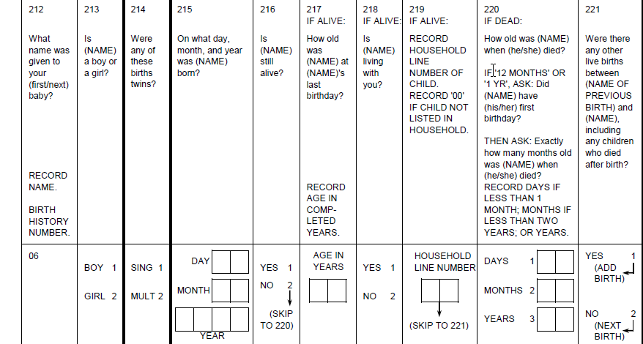

1. The parent or legal guardian of the child named in Q212
2. The head of the household in which the child lives
3. The twin of the child, if the birth is multiple (Q214=1)
4. The name of the child for which you are asking information about, if the child is listed in the list of household members in the household questionnaire
5. What kinds of personal files may you copy or store on the tablet provided to you for the duration of the survey? *(Circle all that apply*) :
   1. Music files as long as you have checked them for viruses
   2. Pictures of your field team at work and play
   3. Videos you have taken of respondents being measured and tested for learning purposes
   4. No personal files may be copied onto tablets under any circumstances
6. **When you are listing the household members in the household questionnaire, how do you indicate to the tablet system that all members have been listed and you are ready to move on to the next question? (Circle the correct answer)**

a) Enter "00"

b) Click on the "stop" button in the toolbar

c) Answer "No" to the question "Are there any more household members"

d) Use the “Go to end” button on the toolbar

1. **What are the reasons why a household may need to be "shared" between interviewers? (circle all answers that apply)**
2. To allow other interviewers to help interview the eligible women if there are many women in the household
3. To allow other interviewers of a different gender to the interviewer who conducted the household interview to interview respondents in the household
4. To allow biomarkers to be done by another interviewer
5. To save storage space on the PDAs
6. **You have received a shared household from another interviewer. What are the actions that you may take in the tablet concerning this household?** **(circle all answers that apply)**
7. View or modify the household questionnaire for the shared household
8. Conduct interviews for eligible women in that household
9. Display a list of children under five in the shared household eligible for biomarkers
10. Modify ID codes for the shared household
11. **List the three actions you should take to resolve an error message displayed by the tablet :**
12. Read the error message
13. Check to see it if it is a typing error
14. Probe the respondent
15. Make a decision how to resolve the error